ЛАБОРАТОРНА РОБОТА №10

УЯВЛЕННЯ ДАНИХ У WPF

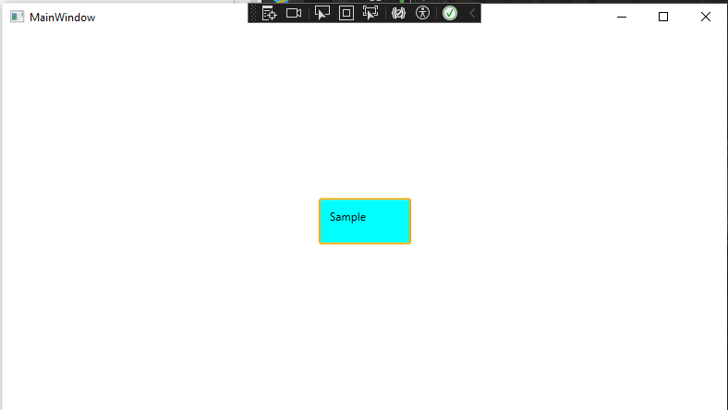

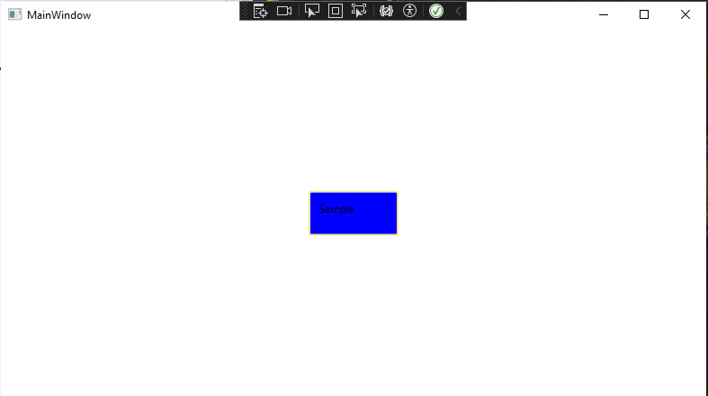

| MainWindow.xaml |
| --- |
| <Window x:Class="WpfApp8.MainWindow"  xmlns="http://schemas.microsoft.com/winfx/2006/xaml/presentation"  xmlns:x="http://schemas.microsoft.com/winfx/2006/xaml"  xmlns:d="http://schemas.microsoft.com/expression/blend/2008"  xmlns:mc="http://schemas.openxmlformats.org/markup-compatibility/2006"  xmlns:local="clr-namespace:WpfApp8"  xmlns:WpfApp8="clr-namespace:WpfApp8"  mc:Ignorable="d"  Title="MainWindow" Height="450" Width="800">  <Window.Resources>  <Style TargetType="Button">  <Setter Property="Template">  <Setter.Value>  <ControlTemplate TargetType="Button">  <Border Name="brd" BorderBrush="Orange" BorderThickness="2"  CornerRadius="2" Background="Aqua">  <ContentPresenter Margin="{TemplateBinding Padding}"/>  </Border>  <ControlTemplate.Triggers>  <Trigger Property="IsMouseOver" Value="True">  <Setter TargetName="brd" Property="Background"  Value="CornflowerBlue"/>  </Trigger>  <Trigger Property="IsPressed" Value="True">  <Setter TargetName="brd" Property="Background" Value="Blue"/>  <Setter TargetName="brd" Property="BorderBrush" Value="Khaki"/>  </Trigger>  </ControlTemplate.Triggers>  </ControlTemplate>  </Setter.Value>  </Setter>  </Style>  </Window.Resources>    <Grid>  <Button Content="Sample" Width="100" Height="50" Padding="10">  <Button.Template>  <ControlTemplate TargetType="Button">  <Border Name="brd" BorderBrush="Orange" BorderThickness="2"  CornerRadius="2" Background="Aqua">  <ContentPresenter Margin="{TemplateBinding Padding}"/>  </Border>  <ControlTemplate.Triggers>  <Trigger Property="IsMouseOver" Value="True">  <Setter TargetName="brd" Property="Background"  Value="CornflowerBlue"/>  </Trigger>  <Trigger Property="IsPressed" Value="True">  <Setter TargetName="brd" Property="Background" Value="Blue"/>  <Setter TargetName="brd" Property="BorderBrush" Value="Khaki"/>  </Trigger>  </ControlTemplate.Triggers>  </ControlTemplate>  </Button.Template>  </Button>  </Grid>  </Window> |